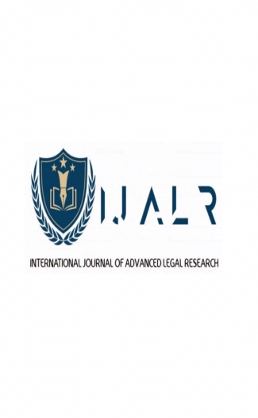
COPYRIGHT AGREEMENT FORM
INTERNATIONAL JOURNAL OF ADVANCED LEGAL RESEARCH

I, , hereby (on behalf of myself and my
co-author) declare that, the Paper titled “
” is an original work. I hereby give consent and hence, assign the copyright of the above work to the editorial team and publisher of International Journal of Advanced Legal Research (herein after referred a “IJALR Journal”) for publication in IJALR Journal in all forms of media. I and my Co-Author are the sole owners of the short Article/Long articles/Book Review/ Case Commentary or Research papers thereof and of all rights, title and interest therein.

I hereby affirm and submit that:
- The Articles/ Book Review/ Case Commentary or Research papers is an original work and has not been previously published and has not been considered elsewhere for publication in any other journal. More so, the Articles/ Book Review/ Case Commentary or Research papers do not infringe any existing copyright or any other third party right.
- The Articles/ Book Review/ Case Commentary or Research papers contains no such material that may be unlawful, defamatory, or which would, if published, in any way whatsoever, violate the terms and conditions as laid down in the agreement.
- A scanned copy or photo copy or email of this (signed, sealed and dated) form is considered equivalent to its corresponding original form in all respects, including legal matters.
- The author(s) confirm that their contribution is original. All acknowledgments/references, wherever applicable, have been acknowledged to the sources and for such excerpts from copyrighted works as included in the contribution the proper permission is obtained of the copyright holder and author thereof where applicable. The work contains no libelous statements, and the IJALR Journal is in no way responsible for any libelous material written by author, if any and that the work does not infringe upon any copyright, trademark, patent, statutory right, proprietary right or any other legal / professional rights of others.

- All disputes are subjected to the jurisdiction of Sirsa, Haryana, India.

- The grant of rights to IJALR Journal does not infringe any clause of this agreement.

Signature of Author(s)/ Name:
Designation & Institution:
Contact No. and Email Address:

